The estimated time for each part is indicated by E.T.

|  |  |
| --- | --- |
| Names | Ids |
| Randa Zyad Hussein | 20196095 |
| Mariam Mohamed Negm | 20196053 |

# MCQ Write the letter of the most correct answer [E.T. =30][30 marks]

1. What are software quality factors?

|  |  |
| --- | --- |
| 1. Product operation requirements | 1. Product transition requirements |
| 1. Product revision requirements | 1. All of the above |

1. Define correctness :

|  |  |
| --- | --- |
| 1. Easy to use | 1. Data secured |
| 1. Software does what customer wants | 1. System can be changed easily |

1. one of the quality factors of product transition requirement:

|  |  |
| --- | --- |
| 1. Correctness | 1. Interoperability |
| 1. Integrity | 1. None of the above |

1. one of the quality factors of product revision requirement?

|  |  |
| --- | --- |
| 1. Correctness | 1. Maintainability |
| 1. Integrity | 1. All of the above |

1. SQFs which are not independent?

|  |  |
| --- | --- |
| 1. Integrity & maintainability | 1. Integrity & reliability |
| 1. Integrity & efficiency | 1. None of the above |

1. measuring correctness:

|  |  |
| --- | --- |
| 1. KLOC | 1. MTTC |
| 1. Probability of attack | 1. None of the above |

1. ____ refers to a different set of tasks that ensure that the software that has been built is traceable to customer requirements.

|  |  |
| --- | --- |
| 1. verification | 1. testing |
| 1. validation | 1. None of mention |

1. The complexity measurement method used by counting the number of independent paths is : .

|  |  |
| --- | --- |
| 1. LOC metric | 1. Black box |
| 1. McCabe’s method | 1. White box |

1. Use _____ to find out wrong requirement early in the development process

|  |  |
| --- | --- |
| 1. testing | 1. validation |
| 1. prototype | 1. verification |

1. development testing consists of

|  |  |
| --- | --- |
| 1. unit testing | 1. system testing |
| 1. Integration testing | 1. All of mention |

1. McCabe cyclomatic complexity

|  |  |
| --- | --- |
| 1. Depends on the size of the program | 1. Only measures executable paths |
| 1. Reduces the number of linearly independent paths | 1. Help us evaluate the risk of program |

1. cyclomatic complexity is carried out in

|  |  |
| --- | --- |
| 1. White box testing | 1. Load testing |
| 1. Black box | 1. Loop testing technique |

1. cyclomatic complexity is equal to

|  |  |
| --- | --- |
| 1. Number of Independent paths | 1. Number of paths |
| 1. Number of edges | 1. None of the above |

1. Computing cyclomatic complexity:

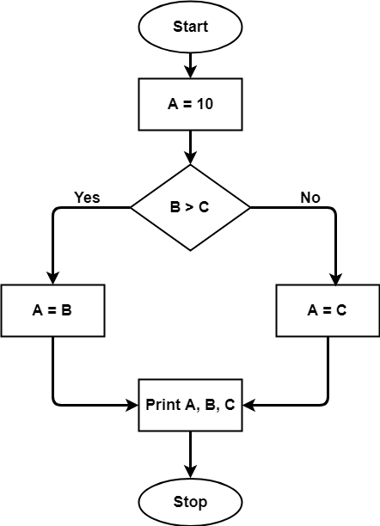

|  |  |
| --- | --- |
| 1. 2 | 1. 3 |
| 1. 4 | 1. 7 |

1. Compute cyclomatic complexity:

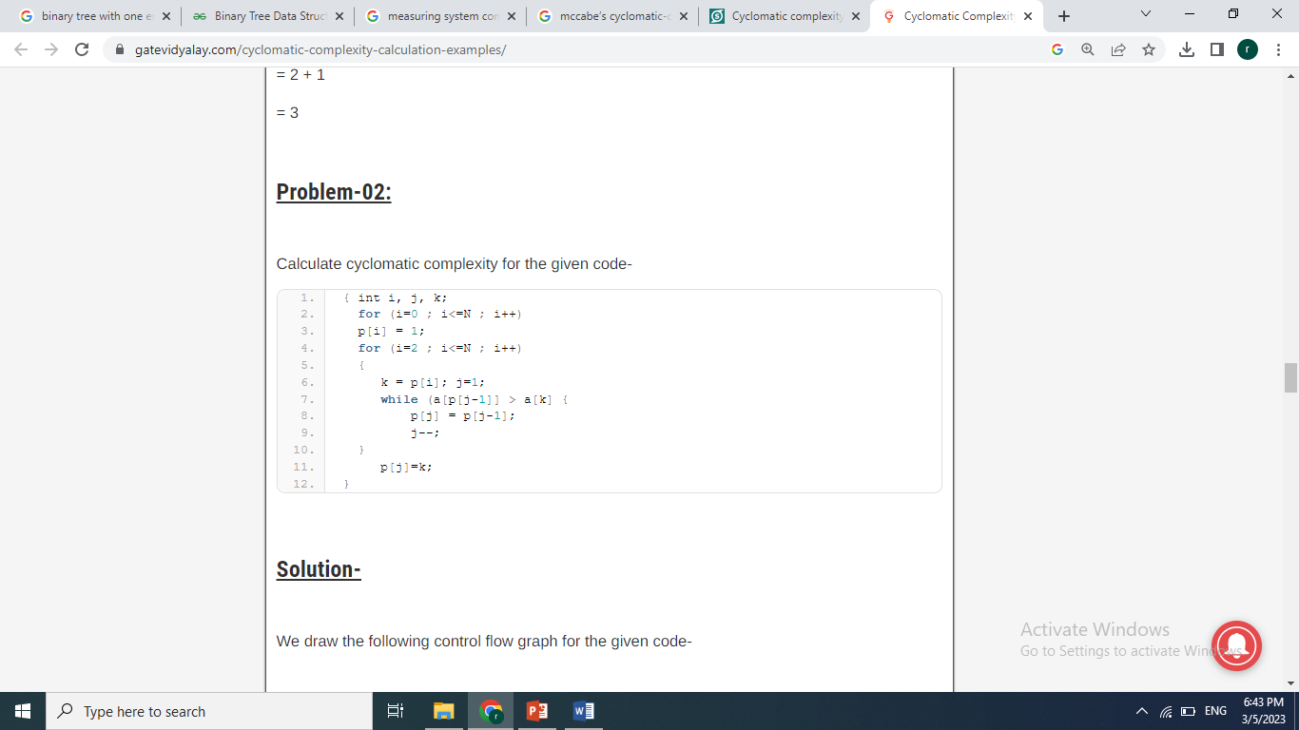

|  |  |
| --- | --- |
| 1. 9 | 1. 3 |
| 1. 4 | 1. 7 |

1. Compute depth-of-inheritance(DIT) metric:

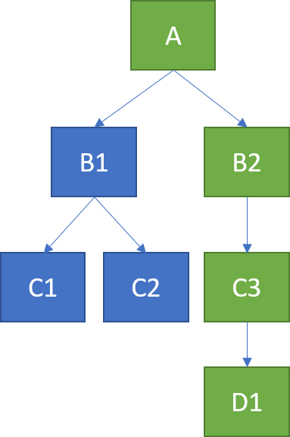

|  |  |
| --- | --- |
| 1. 1 | 1. 2 |
| 1. 3 | 1. 4 |

1. Compute number of children(NOC) for class A

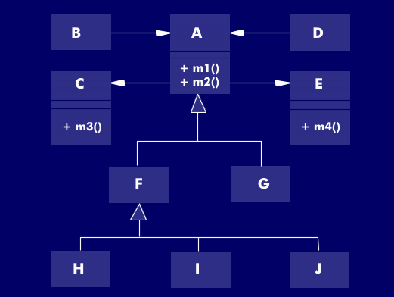

|  |  |
| --- | --- |
| 1. 1 | 1. 3 |
| 1. 2 | 1. 4 |

1. compute Coupling-between-objects for class A



|  |  |
| --- | --- |
| 1. 2 | 1. 3 |
| 1. 4 | 1. 5 |

1. black box testing scenario:

“We will test the behavior of withdrawing money from a bank account. An amount from $1 to $500 is considered valid. Otherwise, any value greater than $500 and less than $1 is considered invalid. Consider entering pin which 4 numeric characters. Otherwise, any alphabet character is not valid and if more than or less than 4 characters are entered considered invalid”

Answer the following question regarding black box testing:

choose a best set of test data for amount:

|  |  |
| --- | --- |
| 1. 100,200,305,400 | 1. 1,2,250,499,500 |
| 1. -10,1,500,501 | 1. 300,400,500,1000 |

1. Pattern for solving certain code scenarios

|  |  |
| --- | --- |
| 1. Design patterns | 1. MVC |
| 1. architecture patterns | 1. None of the above |

1. Which of the following describes a message-passing taxonomy for a component-based architecture that provides services to clients upon demand?

|  |  |
| --- | --- |
| 1. SOA | 1. EBS |
| 1. GEC | 1. None of the above |

1. Point out the correct statement.

|  |  |
| --- | --- |
| 1. Service Oriented Architecture (SOA) describes a standard method for requesting services from distributed components and managing the results | 1. SOA provides the translation and management layer in an architecture that removes the barrier for a client obtaining desired services |
| 1. With SOA, clients and components can be written in different languages and can use multiple messaging protocols | 1. All of the mentioned |

1. Which of the following is a repeatable task within a business process?

|  |  |
| --- | --- |
| 1. Service | 1. bus |
| 1. methods | 1. all of the above |

1. JSON stands for _______.

|  |  |
| --- | --- |
| 1. JavaScript Object Notation | 1. Java Object Notation |
| 1. JavaScript Object Normalization | 1. JavaScript object-oriented notation |

1. The JSON syntax is a subset of the _____syntax.

|  |  |
| --- | --- |
| 1. Ajax | 1. php |
| 1. JavaScript | 1. HTML |

1. The JSON syntax, array is written within in ____

|  |  |
| --- | --- |
| 1. Square brackets | 1. parentheses |
| 1. curly brackets | 1. none of the above |

1. which is the correct symbol to insert a comment in JSON?

|  |  |
| --- | --- |
| 1. // | 1. /*…*/ |
| 1. <!-- … --> | 1. JSON doesn’t support comments |

1. JSON names (keys) requires double quotes?

|  |  |
| --- | --- |
| 1. true | 1. false |